**DAILY ONLINE ACTIVITIES SUMMARY**

|  |  |  |  |  |  |  |  |  |
| --- | --- | --- | --- | --- | --- | --- | --- | --- |
| **Date:** | **19/05/2020** | | | | | **Name:** | **Manish B Shriyan** | |
| **Sem & Sec** | **8th sem B sec** | | | | | **USN:** | **4AL16CS131** | |
| **Online Test Summary** | | | | | | | | |
| **Subject** | | **BDA** | | | | | | |
| **Max. Marks** | | **30** | | **Score** | | | **23** | |
| **Certification Course Summary** | | | | | | | | |
| **Course** | **AWS DeepRacer : Driven by Reinforcement Learning** | | | | | | | |
| **Certificate Provider** | | | **AWS** | | **Duration** | | | **90 Mins** |
| **Coding Challenges** | | | | | | | | |
| **Problem Statement:**  **Using methods charAt() & length() of String class, write a program to print the frequency of each character in a string.** | | | | | | | | |
| **Status: Solved** | | | | | | | | |
| **Uploaded the report in Github** | | | | | **Uploaded** | | | |
| **If yes Repository name** | | | | | **ManishShriyan** | | | |
| **Uploaded the report in slack** | | | | | **Yes** | | | |

Online Test Details:

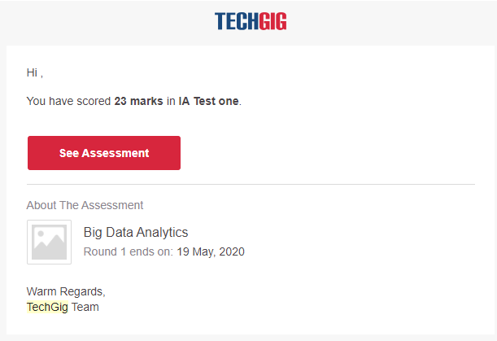

Certification Course Details:

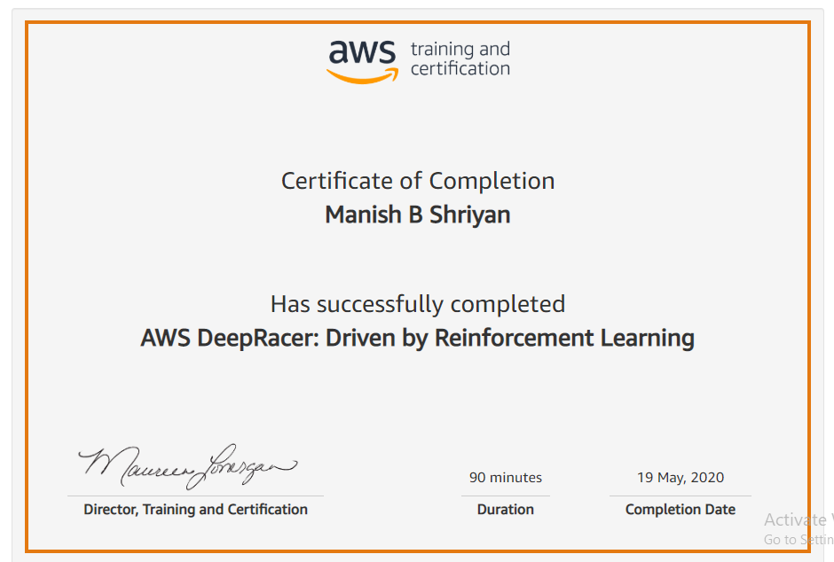

Coding Challenges Details:

|  |
| --- |
| package shortestpalindromeexample.java; |
|  | import java.util.Scanner; |
|  |  |
|  | public class ShortestPalindromeDemo { |
|  |  |
|  | public static String shortestPalindrome(String str) { |
|  |  |
|  | int x=0; |
|  | int y=str.length()-1; |
|  |  |
|  | while(y>=0){ |
|  | if(str.charAt(x)==str.charAt(y)){ |
|  | x++; |
|  | } |
|  | y--; |
|  | } |
|  |  |
|  | if(x==str.length()) |
|  | return str; |
|  |  |
|  | String suffix = str.substring(x); |
|  | String prefix = new StringBuilder(suffix).reverse().toString(); |
|  | String mid = shortestPalindrome(str.substring(0, x)); |
|  |  |
|  | return prefix+mid+suffix; |
|  | } |
|  |  |
|  | public static void main(String[] args) { |
|  |  |
|  | Scanner in = new Scanner(System.in); |
|  |  |
|  | System.out.println("Enter a String to find out shortest palindrome"); |
|  |  |
|  | String str=in.nextLine(); |
|  |  |
|  | System.out.println("Shortest palindrome of "+str+" is "+shortestPalindrome(str)); |
|  |  |
|  | } |
|  |  |
|  |  |
|  | ======================================================================================================================================== |
|  | ======================================================================================================================================== |
|  |  |
|  |  |
|  | import java.util.Stack; |
|  |  |
|  | // Data Structure to store a linked list node |
|  | class Node { |
|  | int data; |
|  | Node next; |
|  |  |
|  | Node(int i) |
|  | { |
|  | this.data = i; |
|  | this.next = null; |
|  | } |
|  | }; |
|  |  |
|  | class Main |
|  | { |
|  | // Function to determine if a given linked list is palindrome or not |
|  | public static boolean isPalindrome(Node head) |
|  | { |
|  | // construct an empty stack |
|  | Stack<Integer> s = new Stack<>(); |
|  |  |
|  | // push all elements of the linked list into the stack |
|  | Node node = head; |
|  | while (node != null) { |
|  | s.push(node.data); |
|  | node = node.next; |
|  | } |
|  |  |
|  | // traverse the linked list again |
|  | node = head; |
|  | while (node != null) |
|  | { |
|  | // pop the top element from the stack |
|  | int top = s.pop(); |
|  |  |
|  | // compare the popped element with current node's data |
|  | // return false if mismatch happens |
|  | if (top != node.data) { |
|  | return false; |
|  | } |
|  |  |
|  | // advance to the next node |
|  | node = node.next; |
|  | } |
|  |  |
|  | // we reach here only when the linked list is palindrome |
|  | return true; |
|  | } |
|  |  |
|  | public static void main(String[] args) |
|  | { |
|  | Node head = new Node(1); |
|  | head.next = new Node(2); |
|  | head.next.next = new Node(3); |
|  | head.next.next.next = new Node(2); |
|  | head.next.next.next.next = new Node(1); |
|  |  |
|  | if (isPalindrome(head)) { |
|  | System.out.print("Linked List is a palindrome."); |
|  | } else { |
|  | System.out.print("Linked List is not a palindrome."); |
|  | } |
|  | } |
|  | } |